Assignment 2 - Measurement Systems
  - Part 1 – Test Coverage
The first part of this assignment is about implementing a metric based on an interview from someone in the industry. I interviewed a friend who works as a software engineer in a French company. After listing some metrics they used, I decided to implement a test coverage evaluation. The test coverage was evaluated using coverage.py.
The generated coverage report contains coverage in percent at file, function and class levels. Fore each file, function and class, the reports provide a percent of coverage. I used that coverage and counted when coverage is 100%, when it is between 90% and 99%, and when it is below 90%. I then divided by the total amount files, functions, or classes to get the proportion of each interval. Finally, I compared the coverage from one week to another to see if the proportion of 100% increases or decreases. The result of this is printed in a table where lines are green when the proportion of 100% increased from the previous iteration, red when it decreased and yellow when is it equal. The following table show the result on psf/black, with coverage calculated every week between the 2nd of March 2026 and the 17th of August 2026:
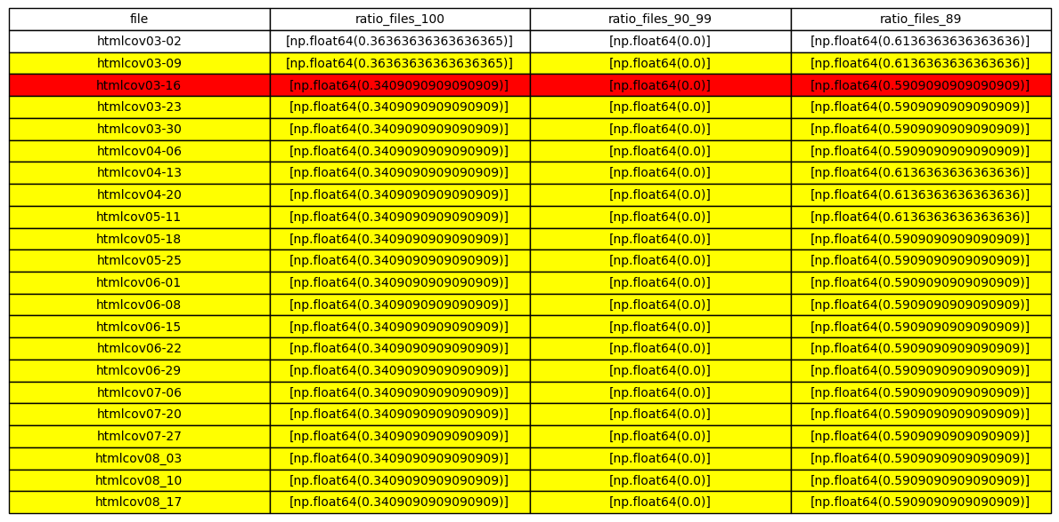
The black repository does not change frequently enough to really see much evolution in coverage. To test the where the proportion of 100% coverages increase from the previous week, I manually modified the test to make the test pass on lines 6 and 11:
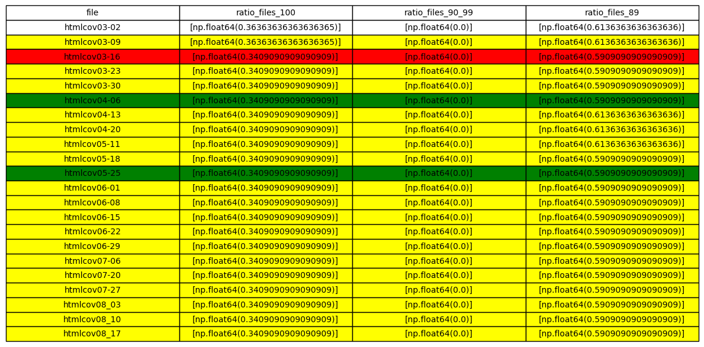
  - Part 2 – Readability Score
For the second part of the assignment, I will implement a readability penalty score. I decided to focus on identifiers’ readability by implementing a penalty score that increases with problems in the identifiers. 4 aspects are considered in the evaluation:
- Length of identifiers: On one hand, an identifier too short risk being uninformative name. On the other hand, an identifier too long makes the code hard to read, especially when used inside of calculations.
- Word count in a single identifier: A penalty is implemented when too many words compose an identifier. While this is tied to the length penalty, having both penalties allow to filter identifiers with multiple very short words, such as acronym or shorten words (for example avgPredPosTestN is just a bit long but uses too many words).
- Generic word usage: Using generic words can lead to ambiguous identifiers that are difficult to understand without the context of the code. For example, a variable named temp can be any type of variable and is unhelpful to debug the code.
- Mix of camel and snake cases: Camel and snake cases are identified in identifiers, and a penalty is applied if they are mixed within the same code file.
A final readability score is computed by taking the average of the 4 penalties. The penalty scores are computed for every file in a code base. A global score is then calculated for the complete codebase by taking the average scores of every file. The total count of camel and snake cases are also implemented.
The score is calculated using the psf/black repository and the average penalties are reported below:
Penalty score | Generic penalty | Length penalty | Word count penalty | Mixed convention | Convention count (snake, camel, other)
0.3007509293419102 | 85 | 0.028213443799986696 | 0.8129475755518274 | 0.09454710053155074 | [176, 98, 3]

